Thumati Pavan Venkata Narendra Kumar

EMP-ID-289219

Step-1: Clone a project from GitHub in a terminal from visual studio code using git clone “link”.

Step-2: Go to the folder where we created files and open the git bash from that location.

Step-3: Before that create a repository in GitHub naming portfolio and include readme file.

Step-4: Initialize the git using git Init command.

Step-5: Connect the remote repo on GitHub to the git by using the command “**git remote add origin “link””**. (Link is available in GitHub under code button)

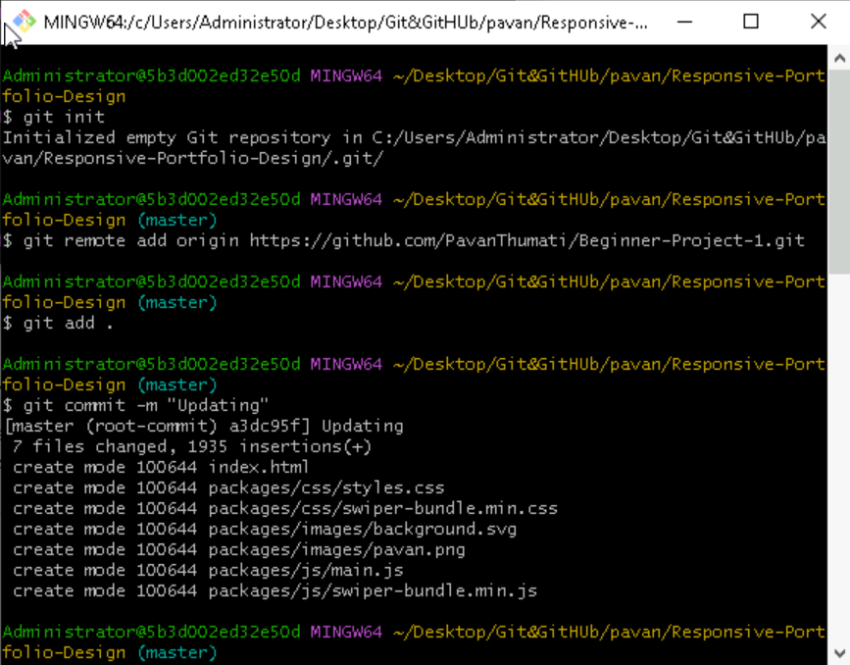

Figure 1:Initial commands.

Step-6: Use git pull origin main command to pull the files (like readme) from the remote repo to local repo.

Step-7: Add the files that are present in the folder (index.html, and packages folder which contains style.css, script.js and images) into the staging area by using “**git add .**”.

Step-8: To know the status of the files that are added to staging area type the “**git status”** command.

Step-9: Commit the changes by using “**git commit -m “Updating”**”.

Step-10: Now push the files that are committed (saved) previously by using git push origin main. Check whether the files have came to GitHub if any error occurs follow the previous steps. By using “**git push origin HEAD:main**” command.

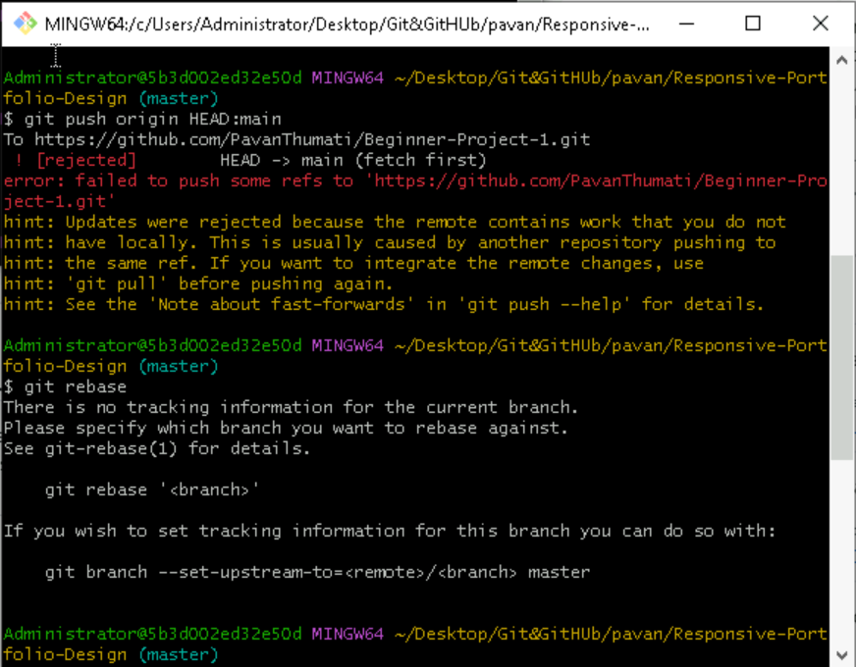

Figure 2:Pushing to GITHUB.

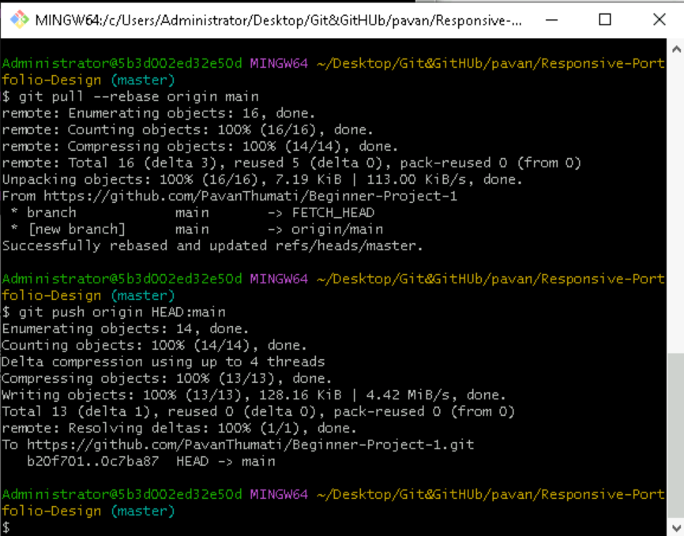

Figure 3 pushing to GITHUB.

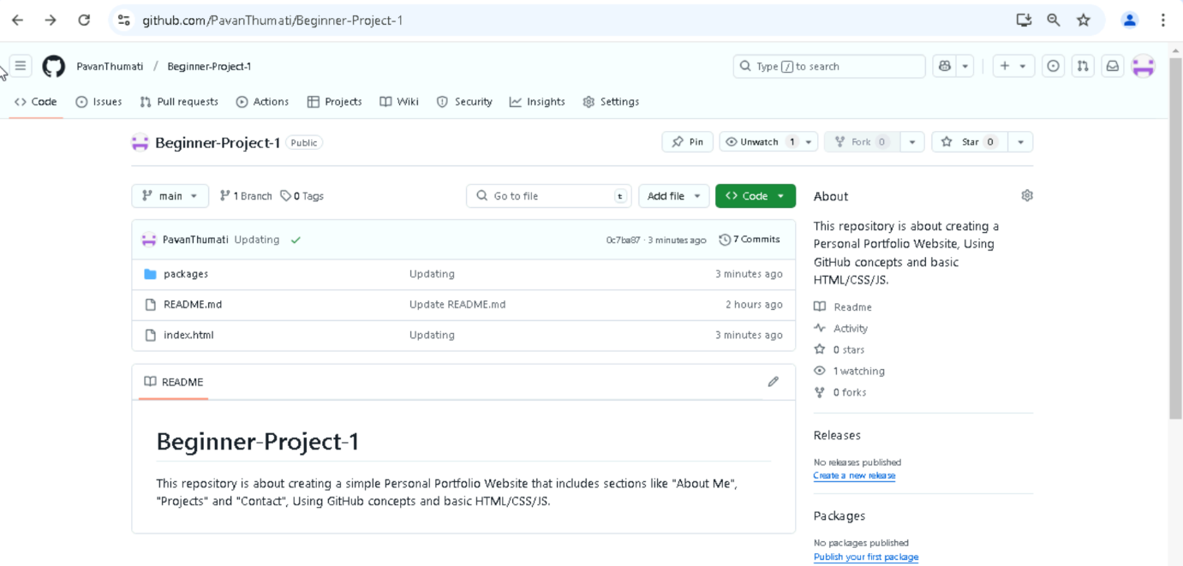

Figure 4:GitHub repo after pushing file.

Step-11: Go to settings -> pages and select the main branch and click save to deploy and after the completion of deployment click on the link provided by GitHub.

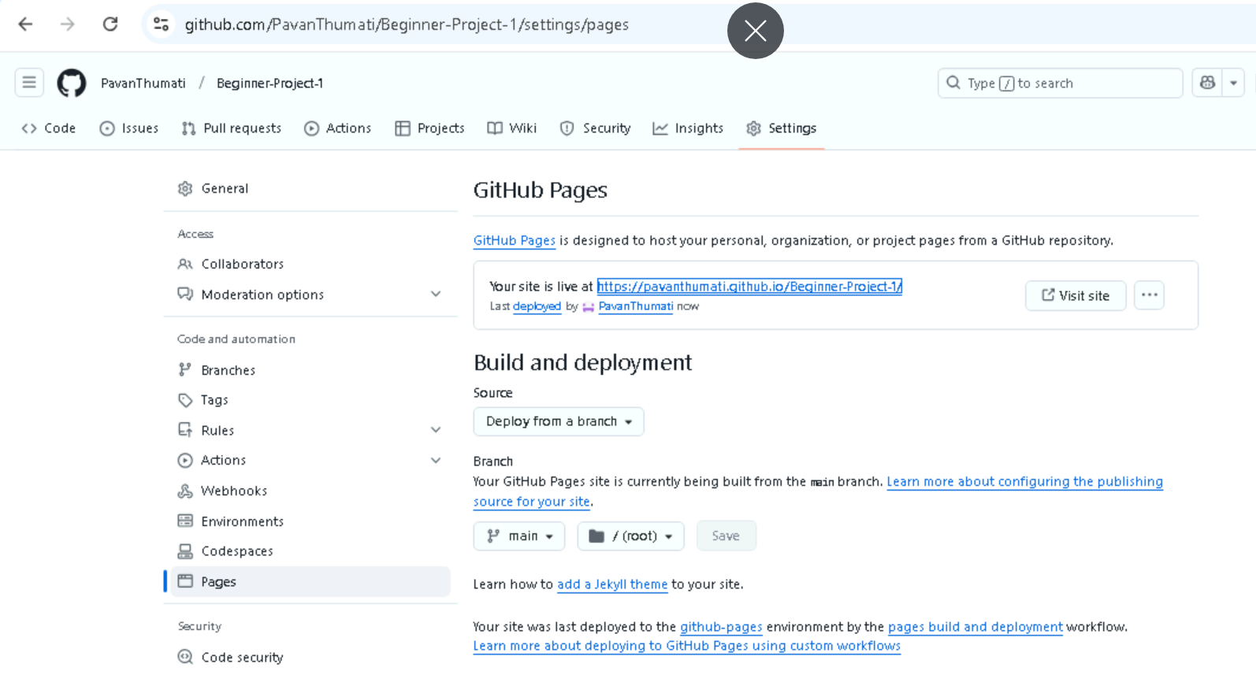

Figure 5:Link to portfolio.

